Research Cruise Summary Report

2025

Project Name: | Seasonal Survey of Scallop Fishery on the Eastern Part of Georges Bank
Vessel Name: | Atlantic
Departure Date: | 1/12/2026
Land Date: | 1/17/2026
Port: | New Bedford, MA
Chief Scientist: | Luisa Garcia
Scientific Crew: | Farrell Davis, Cassandra Tillotson, Emily O'Toole
Report Completed by: | Luisa Garcia

Background
The Seasonal Survey Project has been ongoing since 2012, with its spatial coverage modified over time to meet changing Atlantic sea scallop (Placopecten magellanicus) management priorities. Over the last nine years, sampling has focused on the eastern portion of Georges Bank (GB; Figure 1). For the last six years, each survey has employed paired dredge tows using CFF’s 15-foot (4.57 m) Turtle Deflector Dredges, one rigged with a cover net and one without. The two dredges are towed simultaneously for 15 minutes at a target speed of 4.8 knots. Vessel position, heading, and speed are logged every 15 seconds using a GPS-enabled tablet. In addition, the uncovered dredge is instrumented with a Lotek logger recording depth and temperature at 30-second intervals.
Catch is processed separately for each gear type (uncovered dredge, covered dredge, and cover net). All organisms are sorted by species, weighed using a Marel 1100-series motion-compensated scale, and, for selected bycatch species, measured to the nearest centimeter. All fish are enumerated, and up to ten individuals of windowpane flounder (Scophthalmus aquosus), winter flounder (Pseudopleuronectes americanus), or yellowtail flounder (Limanda ferruginea) are randomly selected from uncovered dredge catches for gonadosomatic index determination, with both whole-body and gonad weights recorded.
Scallop catch per tow is quantified in bushels. A one-bushel subsample from each gear type is processed to measure shell height in 5-mm increments. From the uncovered dredge basket, all scallops are shucked and weighed, with up to 30 individuals randomly sampled for detailed biological data including shell height (nearest mm), meat and gonad weight, sex, reproductive stage, and meat quality. Meat condition is qualitatively scored, and any nematodes, orange pustules, or internal blisters are noted.
This report presents some key findings from the third research cruise of the 2025 RSA Seasonal Survey, during which 44 stations were successfully sampled. Sampling at the remaining five stations was not possible due to the presence of lobster buoys in the area.
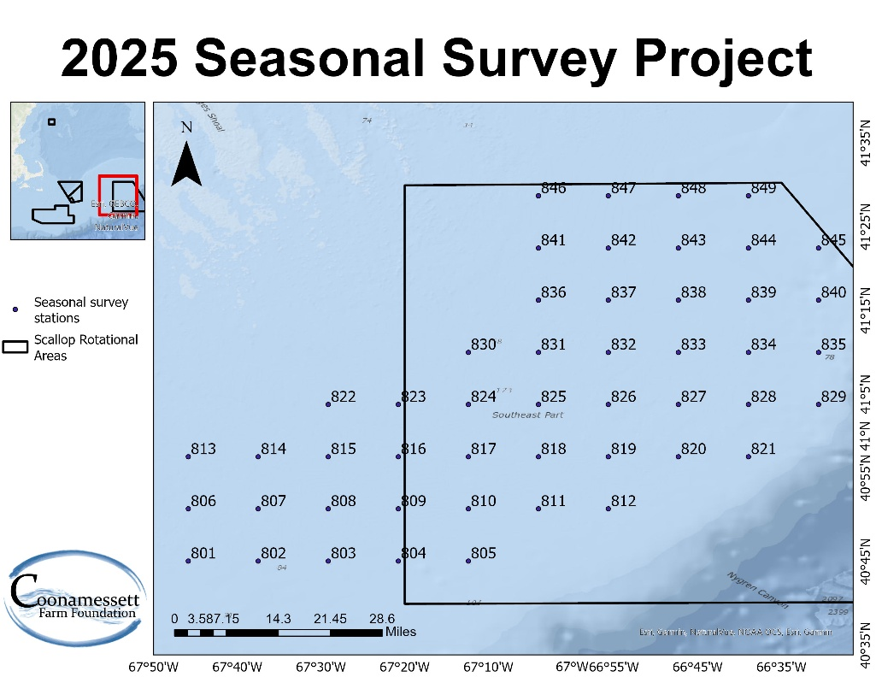
Figure 1. Location of the survey stations for the 2025 seasonal survey on the eastern portion of GB, with stations spaced ~7 nm apart. Crosses indicate stations that were not sampled during the November trip.

Cruise objectives
The main goal of each survey trip is to collect biological and ecological information from all stations across the eastern GB study area (Figure 1). Sampling activities include species identification and counts, measurements of individual shell height or body length, total catch weights, scallop meat weights, gonad weights for scallops and flatfish, as well as sex determination and assessments of reproductive condition. This dataset directly supports the overarching objectives of the project, which are:
- Quantify seasonal biomass of pre-recruit, recruit, and adult Atlantic sea scallops using catch data from a standard dredge equipped with a 40-mm mesh cover net.
- Collect gonadal tissue samples from scallops to examine seasonal and spatial trends in reproductive activity and spawning dynamics across eastern GB.
- Assess seasonal variation in scallop health indicators through macroscopic evaluation of meat color, presence of nematodes, orange pustules, and shell blisters.
- Analyze predator–prey interactions by evaluating the spatial distribution and relative abundance of key predators and their relationship to scallop and clapper distributions.
- Determine spawning periods of yellowtail flounder (Limanda ferruginea) and windowpane flounder (Scophthalmus aquosus) in eastern GB through gonadal examinations.
- Conduct biological assessments of American lobster (Homarus americanus) incidentally caught in dredges, recording metrics such as size, sex, shell hardness, egg presence, shell disease symptoms, and signs of mechanical damage.

Observations & Key Take Aways
An increase in juvenile haddock (Melanogrammus aeglefinus) has been observed over the past four survey trips. During the June and August 2025 trips, a small number of juvenile haddock were unexpectedly encountered, with lengths ranging from 11.1 to 28.5 cm. During the November trip, a higher number of juveniles was observed (n = 76), ranging from 14.7 to 24.1 cm. The number caught increased further to 115 individuals, indicating a growing juvenile presence in the sample area on GB (Figure 2). Comparisons of length-frequency distributions from the previous two trips to the current trip show an increase in mean size, suggesting ongoing growth of this cohort (Figure 3).

Northern sea robin (Prionotus carolinus) abundance was also notably higher during this trip. Although this species has been consistently encountered throughout the seasonal survey, catches increased markedly during the current trip, with a total of 598 individuals recorded (Figure 4). In addition, a torpedo ray (Torpedo nobiliana) was captured. This species has been encountered only a few times over the duration of the project, including the previous trip. The individual measured 78 cm in total length (Figure 5).

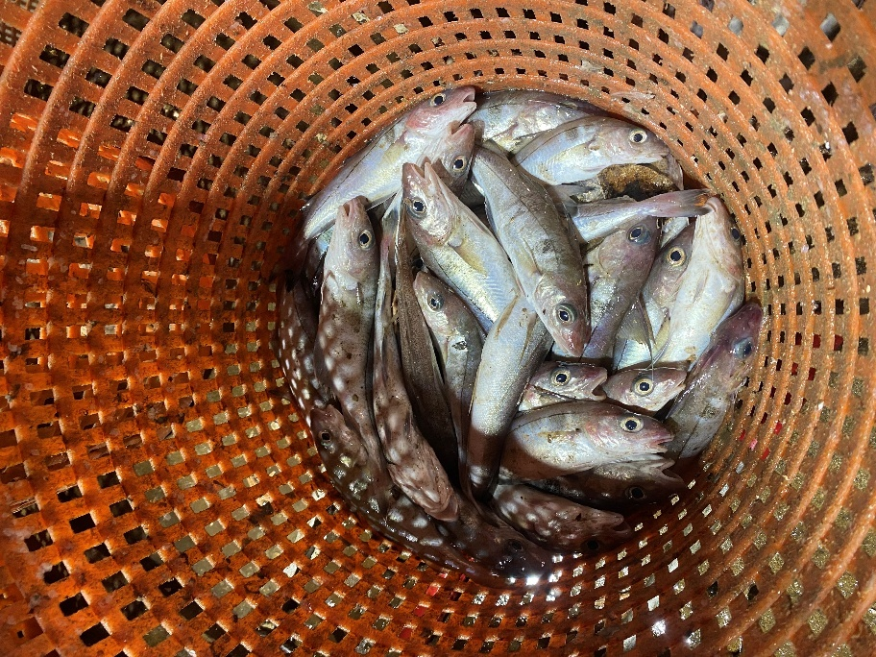
Figure 2. Juvenile haddock captured with the cover net during the January 2026 seasonal survey trip.

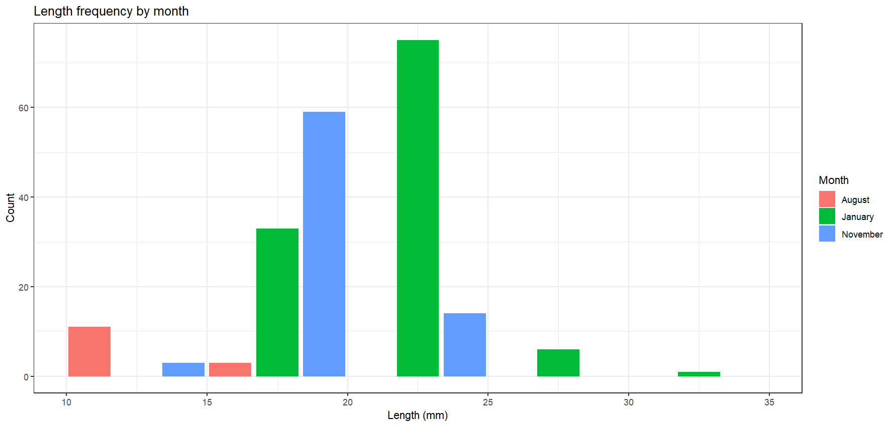
Figure 3. Length–frequency distributions of haddock comparing previous survey trips (August and November 2025) with the most recent trip (January 2026).

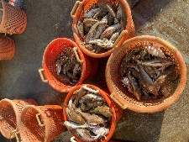
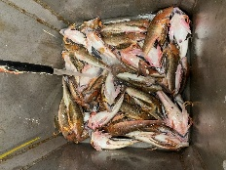
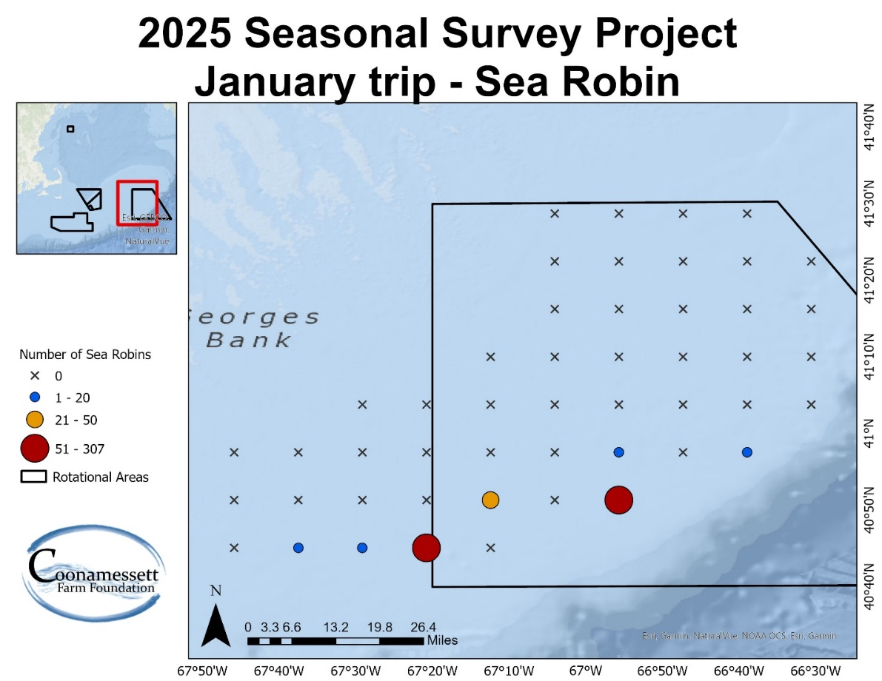
Figure 4. Spatial distribution of sea robin captured during the January 2026 seasonal survey trip, which exhibited elevated abundance relative to previous trips.

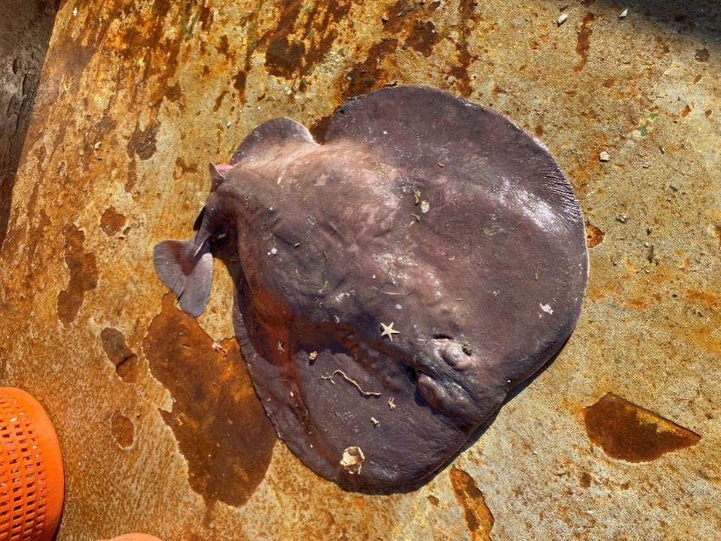
Figure 5. Torpedo rays captured during the January 2026 seasonal survey trip.

Preliminary Results
A total of 44 of the 49 planned stations were surveyed during this trip, as lobster gear restricted sampling in the northern portion of the study area. Despite this limitation, 29 different species were captured (Table 1). The highest trip total of scallop weights were recorded in the cover net (549.45 lbs), followed by the uncovered dredge (496.62 lbs) and covered dredge (307.88 lbs). Several non-target species were also prominent, particularly unclassified skates, which contributed substantial biomass in both the uncovered (1524.7 lbs) and covered dredges (840.12 lbs; Table 1). A total of six flatfish species were captured across all gears. Summer flounder were represented by 42 individuals ranging from 35.5 to 54.4 cm in total length, while windowpane were the most abundant flatfish species, with 226 individuals measuring between 7.3 and 36 cm. A single American plaice and a gray sole measuring 48.9 cm and 39.3 cm, respectively, were captured. Yellowtail flounder catches were low, with 16 individuals ranging from 25.5 to 44.6 cm in length. Fourspot flounder were more frequently observed, with 70 individuals measuring between 25 and 46 cm. In addition to flatfish, 128 monkfish were collected during the trip, ranging from 13.8 to 76 cm in length, indicating the presence of multiple size classes. Lobster bycatch was minimal, with 6 individuals recorded, and carapace lengths ranging from 9 to 13.5 cm.
The overall scallop catch remained low relative to prior years’ surveys. During this trip we observed a greater number of individuals retained by the cover net compared to both the uncovered and covered dredges (Figure 6). The size frequency distributions of scallops varied across gear types, reflecting differences in catch efficiency and selectivity. The uncovered dredge captured a broad range of sizes, with a peak around 115 mm. The covered dredge showed a similar distribution but with fewer individuals. In contrast, the cover net retained more smaller scallops, with a slightly left-shifted distribution and a peak around 95 mm (Figure 6), confirming its efficiency at capturing individuals that are more likely to escape standard scallop dredges.

Table 1. Weights (lbs.) of species captured during the January 2026 seasonal survey trip.
Species caught | Uncovered dredge | Covered dredge | Cover net
American plaice | 1.58 | 0 | 0
Atlantic cod | 0 | 0 | 0.19
Barndoor skate | 21.92 | 57.31 | 2.2
Chain dogfish | 0 | 0 | 0.36
Fourspot flounder | 2.87 | 0.93 | 18.24
Gulfstream flounder | 0 | 0 | 4.16
Haddock | 0 | 0 | 12.95
Illex squid | 0 | 0 | 0.6
Jonah crab | 2.74 | 2.48 | 2.06
Lady crab | 0 | 0 | 0.32
Longhorn sculpin | 0 | 0 | 3.16
Monkfish | 201.95 | 135.49 | 3.65
Northern moon snail | 1.58 | 1.63 | 36.86
Northern sea robin | 112.65 | 29.82 | 48.38
Ocean pout | 0 | 0 | 3.46
Red hake | 4.05 | 1.62 | 292.77
Rock crab | 0.32 | 0 | 0.32
Sea raven | 2.38 | 1.58 | 1.47
Sea scallop | 496.62 | 307.88 | 549.45
Silver hake | 0.64 | 0.19 | 12.52
Spotted hake | 0 | 0 | 0.44
Summer flounder | 18.2 | 7.82 | 6.58
Torpedo ray | 0 | 8.08 | 0
Unclassified skates | 1524.7 | 840.12 | 122.02
Waved whelk | 0.16 | 0.08 | 5.17
Windowpane flounder | 34.72 | 19.28 | 12.3
Witch flounder | 0.54 | 0 | 0
Yellowtail flounder | 2.12 | 1.08 | 3.32

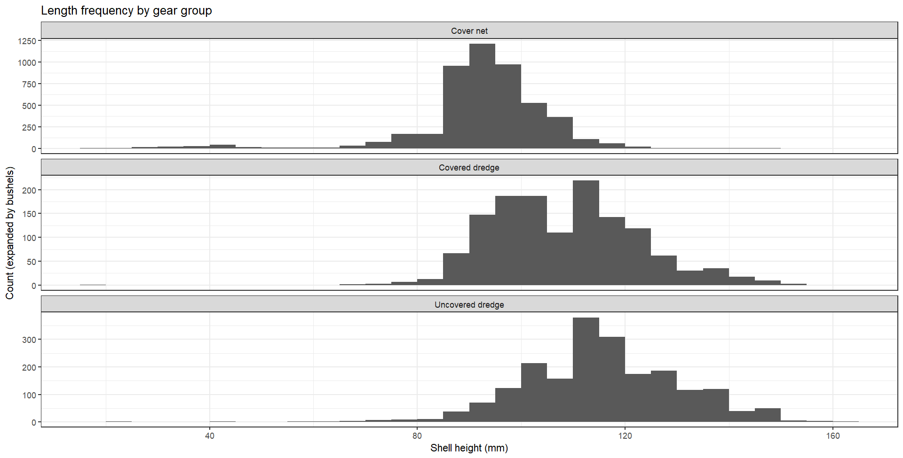
Figure 6. Length-frequency distributions of scallops collected during the January 2026 seasonal survey trip, by gear type (uncovered dredge, covered dredge, and cover net).

