Research Cruise Summary Report

Project Name: | Seasonal Survey of Scallop Fishery on the Eastern Part of Georges Bank
Vessel Name: | Atlantic
Departure Date: | 3/11/2026
Land Date: | 3/16/2026
Port: | New Bedford, MA
Chief Scientist: | Luisa Garcia
Scientific Crew: | Farrell Davis, Cassandra Tillotson, Emily O'Toole
Report Completed by: | Luisa Garcia

Background
The Seasonal Survey Project has been ongoing since 2012, with its spatial coverage modified over time to meet changing Atlantic sea scallop (Placopecten magellanicus) management priorities. Over the last nine years, sampling has focused on the eastern portion of Georges Bank (GB; Figure 1). Each survey since 2020 has employed paired dredge tows using CFF’s 15-foot (4.57 m) Turtle Deflector Dredges, one rigged with a cover net and one without. The two dredges are towed simultaneously for 15 minutes at a target speed of 4.8 knots. Vessel position, heading, and speed are logged every 15 seconds using a GPS-enabled tablet. In addition, the uncovered dredge is instrumented with a Lotek logger recording depth and temperature at 30-second intervals.
Catch is processed separately for each gear type (uncovered dredge, covered dredge, and cover net). All organisms are sorted by species, weighed using a Marel 1100-series motion-compensated scale, and, for selected bycatch species, measured to the nearest centimeter. All fish are enumerated, and up to ten individuals of windowpane flounder (Scophthalmus aquosus), winter flounder (Pseudopleuronectes americanus), or yellowtail flounder (Limanda ferruginea) are randomly selected from uncovered dredge catches for gonadosomatic index determination, with both whole-body and gonad weights recorded.
Scallop catch per tow is quantified in bushels. A one-bushel subsample from each gear type is processed to measure shell height in 5-mm increments. From the uncovered dredge basket, all scallops are shucked and weighed, with up to 30 individuals randomly sampled for detailed biological data including shell height (nearest mm), meat and gonad weight, sex, reproductive stage, and meat quality. Meat condition is qualitatively scored, and any nematodes, orange pustules, or internal blisters are noted.
This report presents some key findings from the third research cruise of the 2025 RSA Seasonal Survey, during which 47 stations were successfully sampled in March 2026. Sampling at the remaining five stations was not possible due to the presence of lobster buoys in the area.
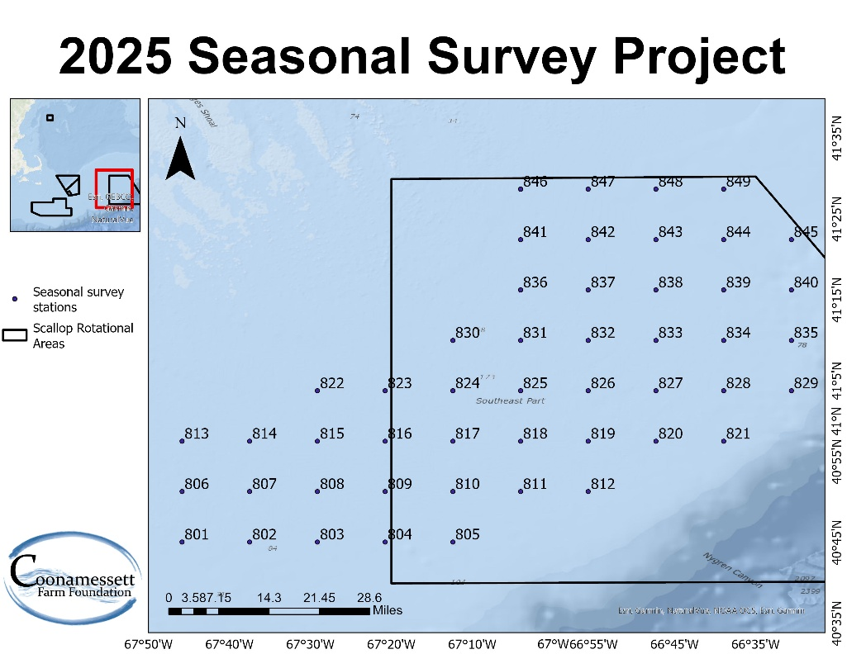
Figure 1. Location of the survey stations for the 2025 seasonal survey on the eastern portion of GB, with stations spaced ~7 nm apart.

Cruise objectives
The main goal of this trip was to collect biological and ecological information from all stations across the eastern GB study area (Figure 1)and subsequently. to compare findings across seasons and years. Sampling activities include species identification and counts, measurements of individual shell height or body length, total catch weights, scallop meat weights, gonad weights for scallops and flatfish, as well as sex determination and assessments of reproductive condition. The dataset from this survey directly supports the overarching objectives of the project, which are:
- Quantify seasonal biomass of pre-recruit, recruit, and adult Atlantic sea scallops using catch data from a standard dredge equipped with a 40-mm mesh cover net.
- Collect gonadal tissue samples from scallops to examine seasonal and spatial trends in reproductive activity and spawning dynamics across eastern GB.
- Assess seasonal variation in scallop health indicators through macroscopic evaluation of meat color, presence of nematodes, orange pustules, and shell blisters.
- Analyze predator–prey interactions by evaluating the spatial distribution and relative abundance of key predators and their relationship to scallop and clapper distributions.
- Determine spawning periods of yellowtail flounder (Limanda ferruginea) and windowpane flounder (Scophthalmus aquosus) in eastern GB through gonadal examinations.
- Conduct biological assessments of American lobster (Homarus americanus) incidentally caught in dredges, recording metrics such as size, sex, shell hardness, egg presence, shell disease symptoms, and signs of mechanical damage.

Observations & Key Take Aways
Contrary to previous trips were juvenile haddock (Melanogrammus aeglefinus) were encountered, this trip was characterized by a notable increase in Atlantic cod (Gadus morhua, Figure 2). A total of 14 individuals were observed, ranging from 22 to 74 cm in total length.
In addition to changes in finfish composition, several atypical gonadal conditions were documented in scallops (Figure 3). These included (a) a specimen exhibiting apparent hermaphroditism, with both ovarian (orange) and testicular (cream/white) tissues present within the same gonad, (b) a individual showing clear spatial heterogeneity in spawning condition, where one portion of the gonad appeared fully spent while the remaining tissue retained mature oocytes, and (c) a case of abnormal gonadal morphology characterized by a localized protuberance or swelling of tissue. Such observations may reflect uneven gamete development within the gonad, incomplete spawning events, or possible physiological stress responses.

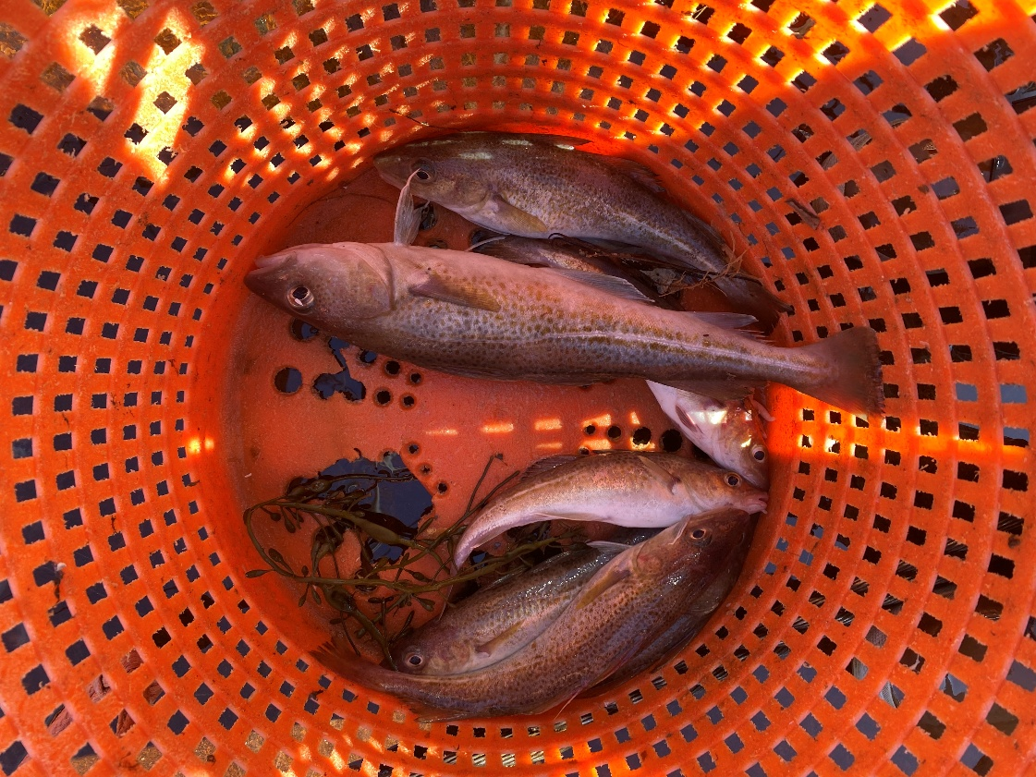
Figure 2. Atlantic cod captured during the March 2026 seasonal survey trip.

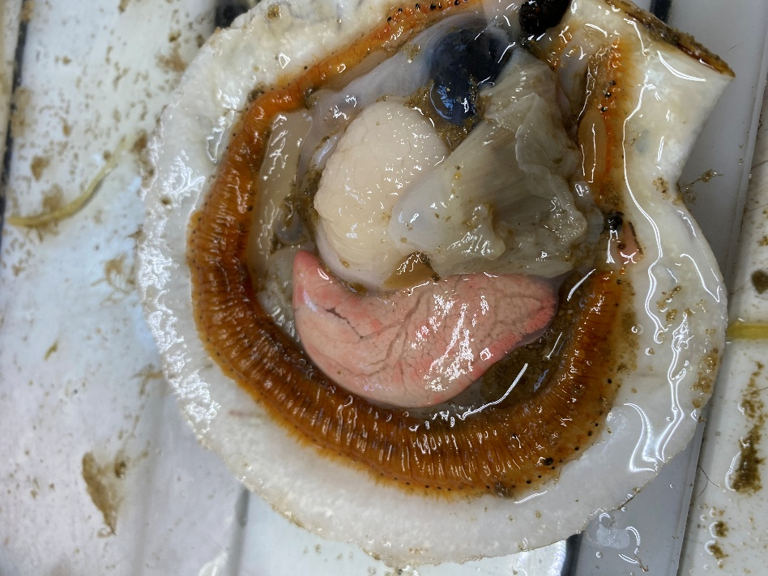  a) | 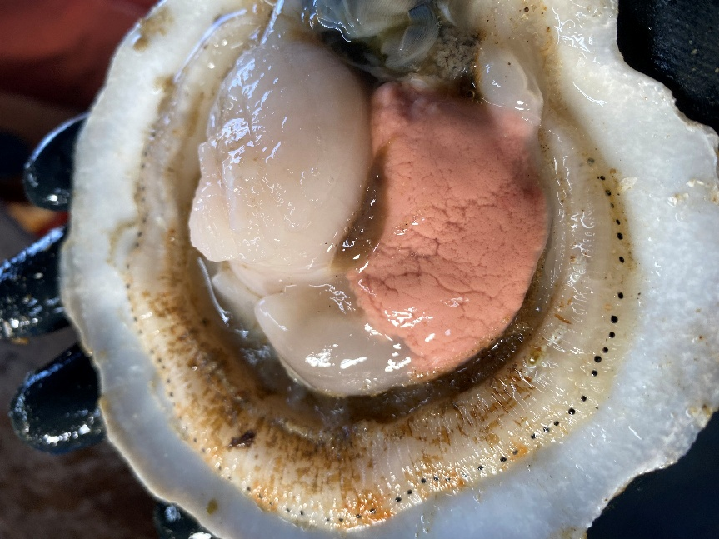  b)
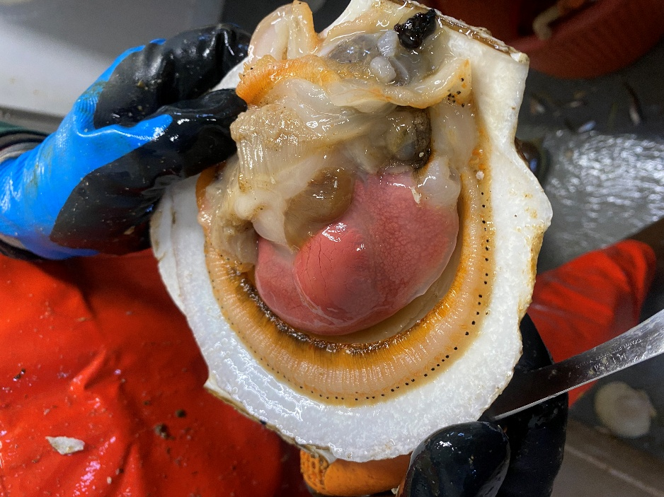
c)
Figure 3. Pictures of atypical gonadal conditions observed in scallops during the Seasonal Survey March trip: a) gonad exhibiting both ovarian (orange) and testicular (white) tissue suggestive of hermaphroditism; b) partially spawned gonad with distinct regions of spent and mature tissue; and c) gonad with abnormal morphology characterized by localized swelling or protuberance.

Preliminary Results
A total of 47 of the 49 planned stations were surveyed during this trip, as lobster gear restricted sampling in two stations located in the northeastern portion of the study area. Despite this limitation, 22 different species were captured (Table 1). The highest trip total of scallop weights were recorded in the uncovered dredge (1388.42 lbs), followed by the covered dredge (910.91 lbs) and the cover net (554.66 lbs). Several non-target species were also prominent, particularly unclassified skates, which contributed substantial biomass in both the uncovered (1524.7 lbs) and covered dredges (840.12 lbs; Table 1). A total of seven flatfish species were captured across all gears. Summer flounder were represented by 11 individuals ranging from 34 to 50 cm in total length, while windowpane were the most abundant flatfish species, with 159 individuals measuring between 8.3 and 33 cm. A single fourspot, a winter, and a gray sole flounder measuring 15 cm, 46 cm and 37.1 cm, respectively, were captured. Yellowtail flounder catches were low, with 6 individuals ranging from 27 to 37 cm in length. In addition to flatfish, bycatch of monkfish and lobster was minimal, with 17 monkfish recorded (12.5 cm - 67 cm total length) and 5 lobsters observed with carapace lengths ranging from 9 to 13.5 cm.
The overall scallop catch remained low relative to prior years’ surveys. During this trip length frequency distributions varied notably among gear types (Figure 4). The cover net captured a broader range of scallops, including a distinct peak of smaller individuals (<60 mm) that were absent from the standard dredges (Figure 4), indicating its effectiveness in retaining small recruit size classes. In contrast, both the covered and uncovered dredges were dominated by larger scallops, with a peak between approximately 90 and 120 mm (Figure 4). Overall, these patterns suggest that standard dredge gear under-samples smaller scallops, while the cover net provides a more complete representation of the population size structure, particularly for pre-recruit and early recruit individuals.
Table 1. Weights (lbs.) of species captured during the March 2026 seasonal survey trip.
Species caught | Uncovered dredge | Covered dredge | Cover net
American plaice | 6.51 | 0 | 0.11
Atlantic cod | 0 | 14.65 | 8.98
Barndoor skate | 24.53 | 10.25 | 5.43
Fourspot flounder | 0 | 0 | 0.04
Gulfstream flounder | 0 | 0 | 3.06
Jonah crab | 13.55 | 3.48 | 1.34
Longhorn sculpin | 0.97 | 0.242 | 14.63
Monkfish | 12.65 | 0 | 7
Northern moon snail | 0.858 | 6.732 | 57.93
Northern searobin | 0 | 0 | 2.11
Ocean pout | 0 | 0 | 8.05
Red hake | 0 | 0 | 1.36
Rock crab | 0.95 | 0.11 | 8.69
Sea raven | 16.06 | 3.9 | 1.1
Sea scallop | 1388.42 | 910.91 | 554.66
Silver hake | 0 | 0 | 4.4
Summer flounder | 4.44 | 11.26 | 2.51
Unclassified skates | 1622.48 | 803.22 | 344.04
Waved whelk | 0.22 | 3.7 | 21.65
Windowpane flounder | 69.04 | 44.31 | 41.71
Winter flounder | 0 | 3.17 | 0
Gray sole flounder | 0 | 0 | 0.77
Yellowtail flounder | 0.90 | 0 | 3.87

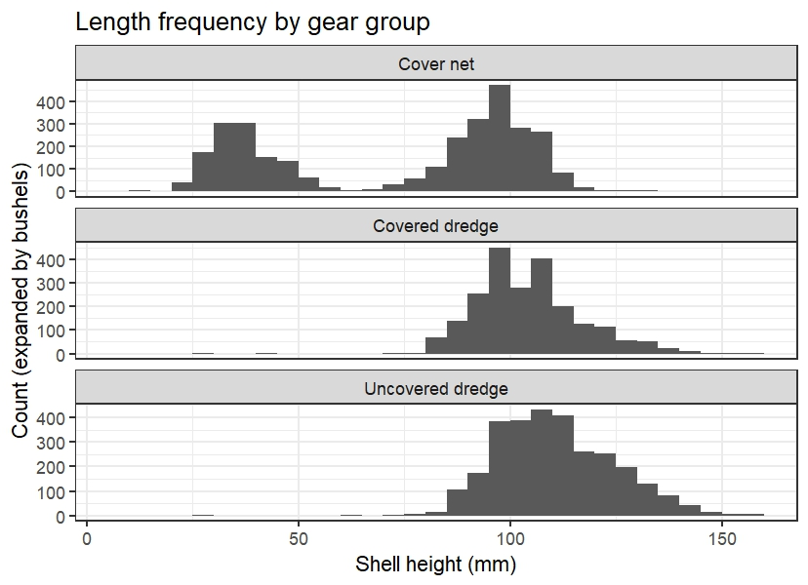
Figure 4. Length-frequency distributions of scallops collected during the March 2026 seasonal survey trip, by gear type (uncovered dredge, covered dredge, and cover net).

